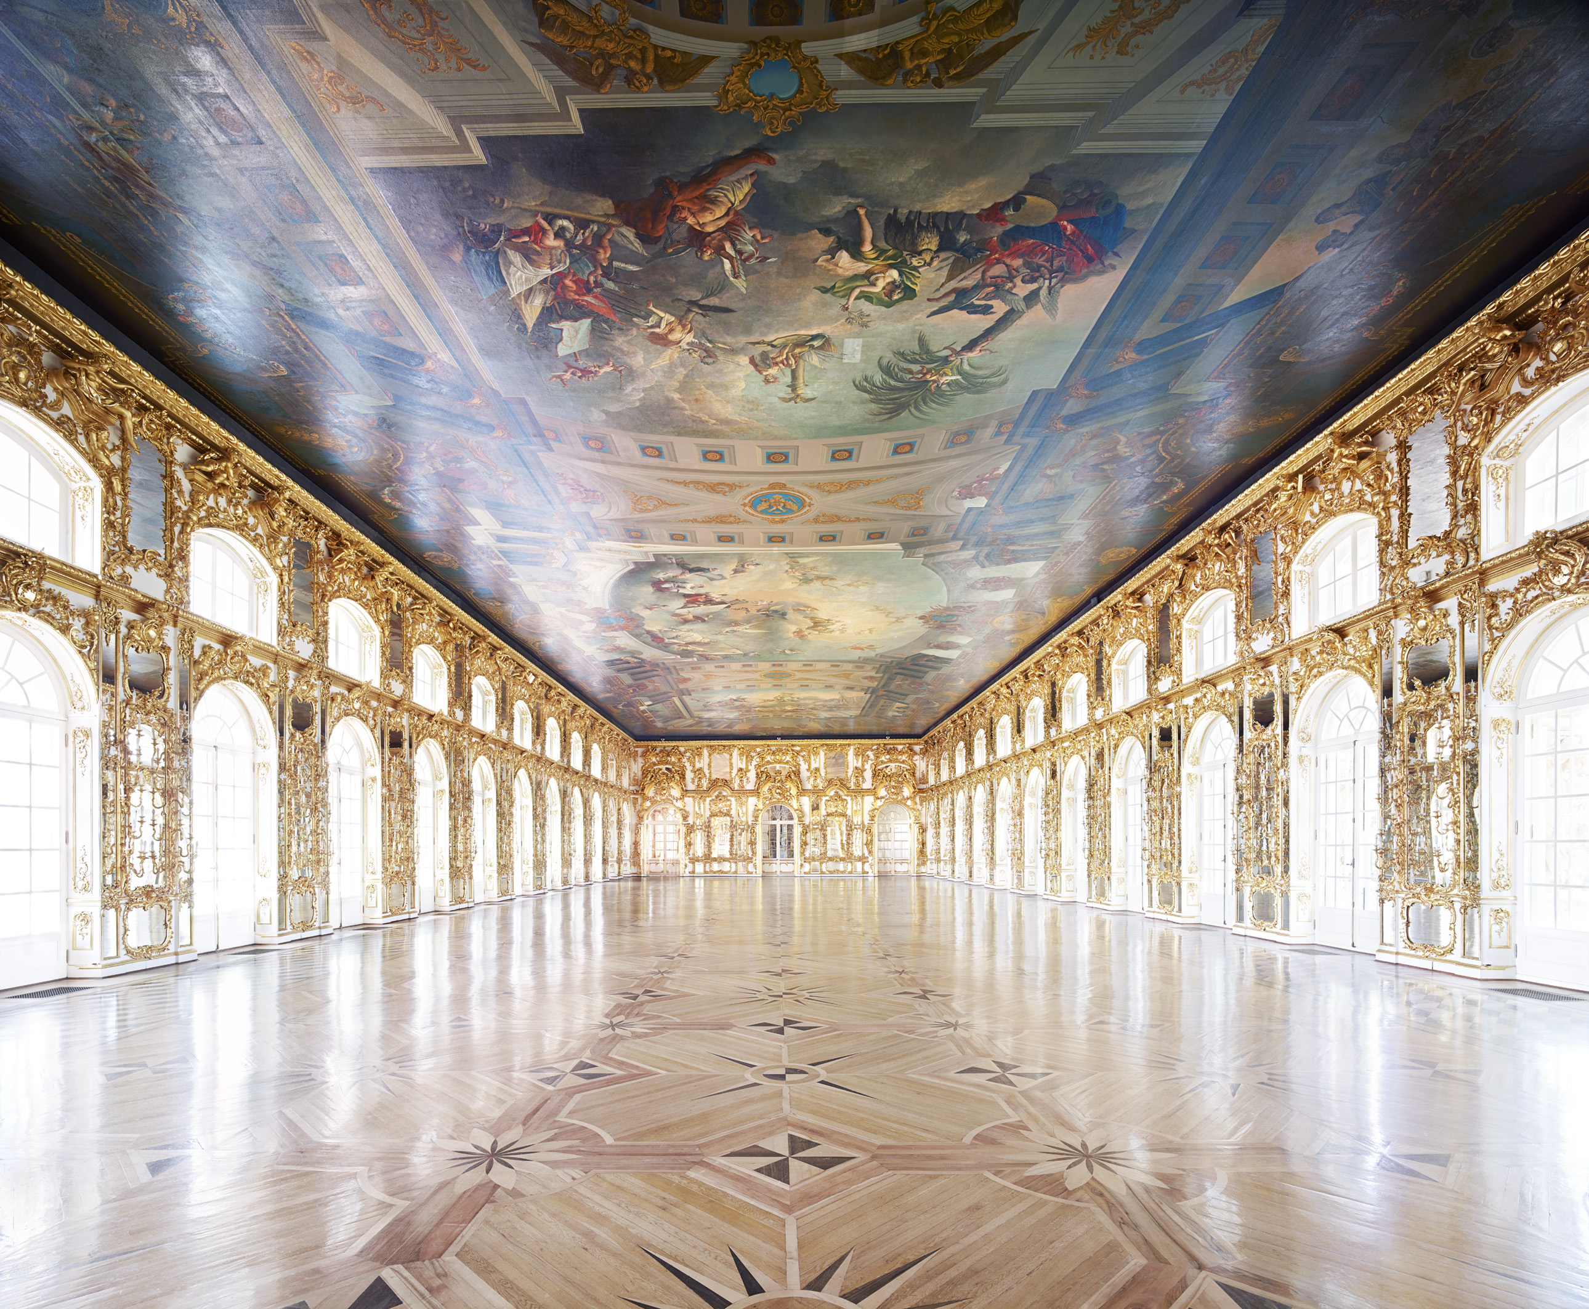
Candida Höfer, Catherine Palace Pushkin St. Petersburg III 2014, C-print, edition of 6, 180 x 210 cm (70 7/8 x 82 5/8 in.)

CANDIDA HÖFER: MEMORY
SELECTED WORKS FROM THE STATE HERMITAGE MUSEUM EXHIBITION

22 March – 28 May 2016
PRIVATE VIEW MONDAY 21 March, 6-8PM

After receiving critical acclaim at the State Hermitage Museum in 2015, Candida Höfer’s latest series, Memory - capturing the splendour of St Petersburg and its magnificent buildings - will travel to Ben Brown Fine Arts Hong Kong in March, coinciding with Art Basel Hong Kong 2016.

The Hermitage Museum, Pushkin Palace, Catherine Palace Pushkin, Mariinsky Theatre, as well as the palaces of Pavlovsk and Yusupov, provide the glorious setting for this new series produced in the summer of 2014. The empty interiors of palaces, opera houses, libraries, museums and theatres are part of the artist’s meticulous and skilful documentation of public spaces which has brought her international prominence. Through her lens, Höfer captures mankind’s greatness - extraordinary buildings and architecture associated with cultural memory and history - yet her spaces are consistently devoid of human presence. For her, ‘an absent guest is often the subject of a conversation’. Here the architecture takes centre stage, losing its attribute of public space, a space created for man, to become an idealised image that could not exist in the public sphere, a world where man has no place.

As curator Nadezda Sinyutina from the State Hermitage Museum asserts, ‘by drawing us into the inaccessible, strange and private life of public spaces and breaking through our inherent difficulties in the perception of architecture, Höfer’s photographs return to public spaces the aura of unique works of art’.

Candida Höfer produces these large-format photographs without digital enhancement or alteration, using long exposure and working solely with the existing light source. The effect is a rare combination of intimacy and scale, in which intricate architectural detail is captured without sacrificing the sense of space and civilised order.

Höfer is a member of the Düsseldorf School (Kunstakademie Düsseldorf) and was a noted pupil of Bernd and Hilla Becher, who pioneered a type of detached objectivity in their work. The Bechers’ black and white photographs of industrial landscapes and architecture embodied a clinical, documentary style, which Höfer has retained in her work through the same neutral and methodical process, yet her large-scale colour prints celebrate the ornateness and rich cultural history of her subjects.

NOTES TO THE EDITOR
Born in 1944 in Eberswalde, Germany, Candida Höfer lives and works in Cologne. After completing her training at the Schmölz-Huth Studio, she began studying with the influential photography duo Bernd and Hilla Becher in 1976, the teachers of other noted Düsseldorf School photographers such as Andreas Gursky, Thomas Struth, Axel Hütte and Thomas Ruff. Höfer’s internationally recognised work has been shown at the Kunsthalle Basel, the Kunsthalle Berne, the Louvre in Paris, the Irish Museum of Modern Art in Dublin, and the State Hermitage Museum in St Petersburg. Höfer has represented Germany at the 2003 Venice Biennale and participated in documenta 11 in 2002, and her photographs are part of major museum and private collections across the globe.

Ben Brown Fine Arts has shown Höfer’s work since 2004, with the gallery’s first show entitled Libraries. Other solo exhibitions featured at the gallery include: Palaces, Theatres, Churches and a Casino (2007), In Italy Part I: Florence (2009), and In Italy Part II: Naples (2009), A Return to Italy (2013), Villa Borghese (2014).

Founded in 2004, Ben Brown Fine Arts has galleries in both London and Hong Kong. The gallery has prominently positioned itself on the contemporary art scene with a stable of artists including Ron Arad, Miquel Barceló, Tony Bevan, Yoan Capote, Ori Gersht, François-Xavier and Claude Lalanne, Vik Muniz, Nabil Nahas, Gavin Turk, Not Vital, Heinz Mack and Tseng Kwong Chi. Also renowned for its strong expertise in 20th Century Italian Art, the gallery has been exhibiting the work of Lucio Fontana, Alighiero Boetti and Mimmo Rotella, amongst others, since its inception. In 2009, Ben Brown Fine Arts pioneered the international art scene in Hong Kong by opening a gallery space in the prominent Pedder Building.

The artist will be present at the Private View.

For further press information and enquires please contact:

Ben Brown Fine Arts
Blake Kwok
blake@benbrownfinearts.com
303 Pedder Building, 12 Pedder Street, Central, Hong Kong
+852 2522 9600
www.benbrownfinearts.com
Monday to Saturday: 11am - 7pm

