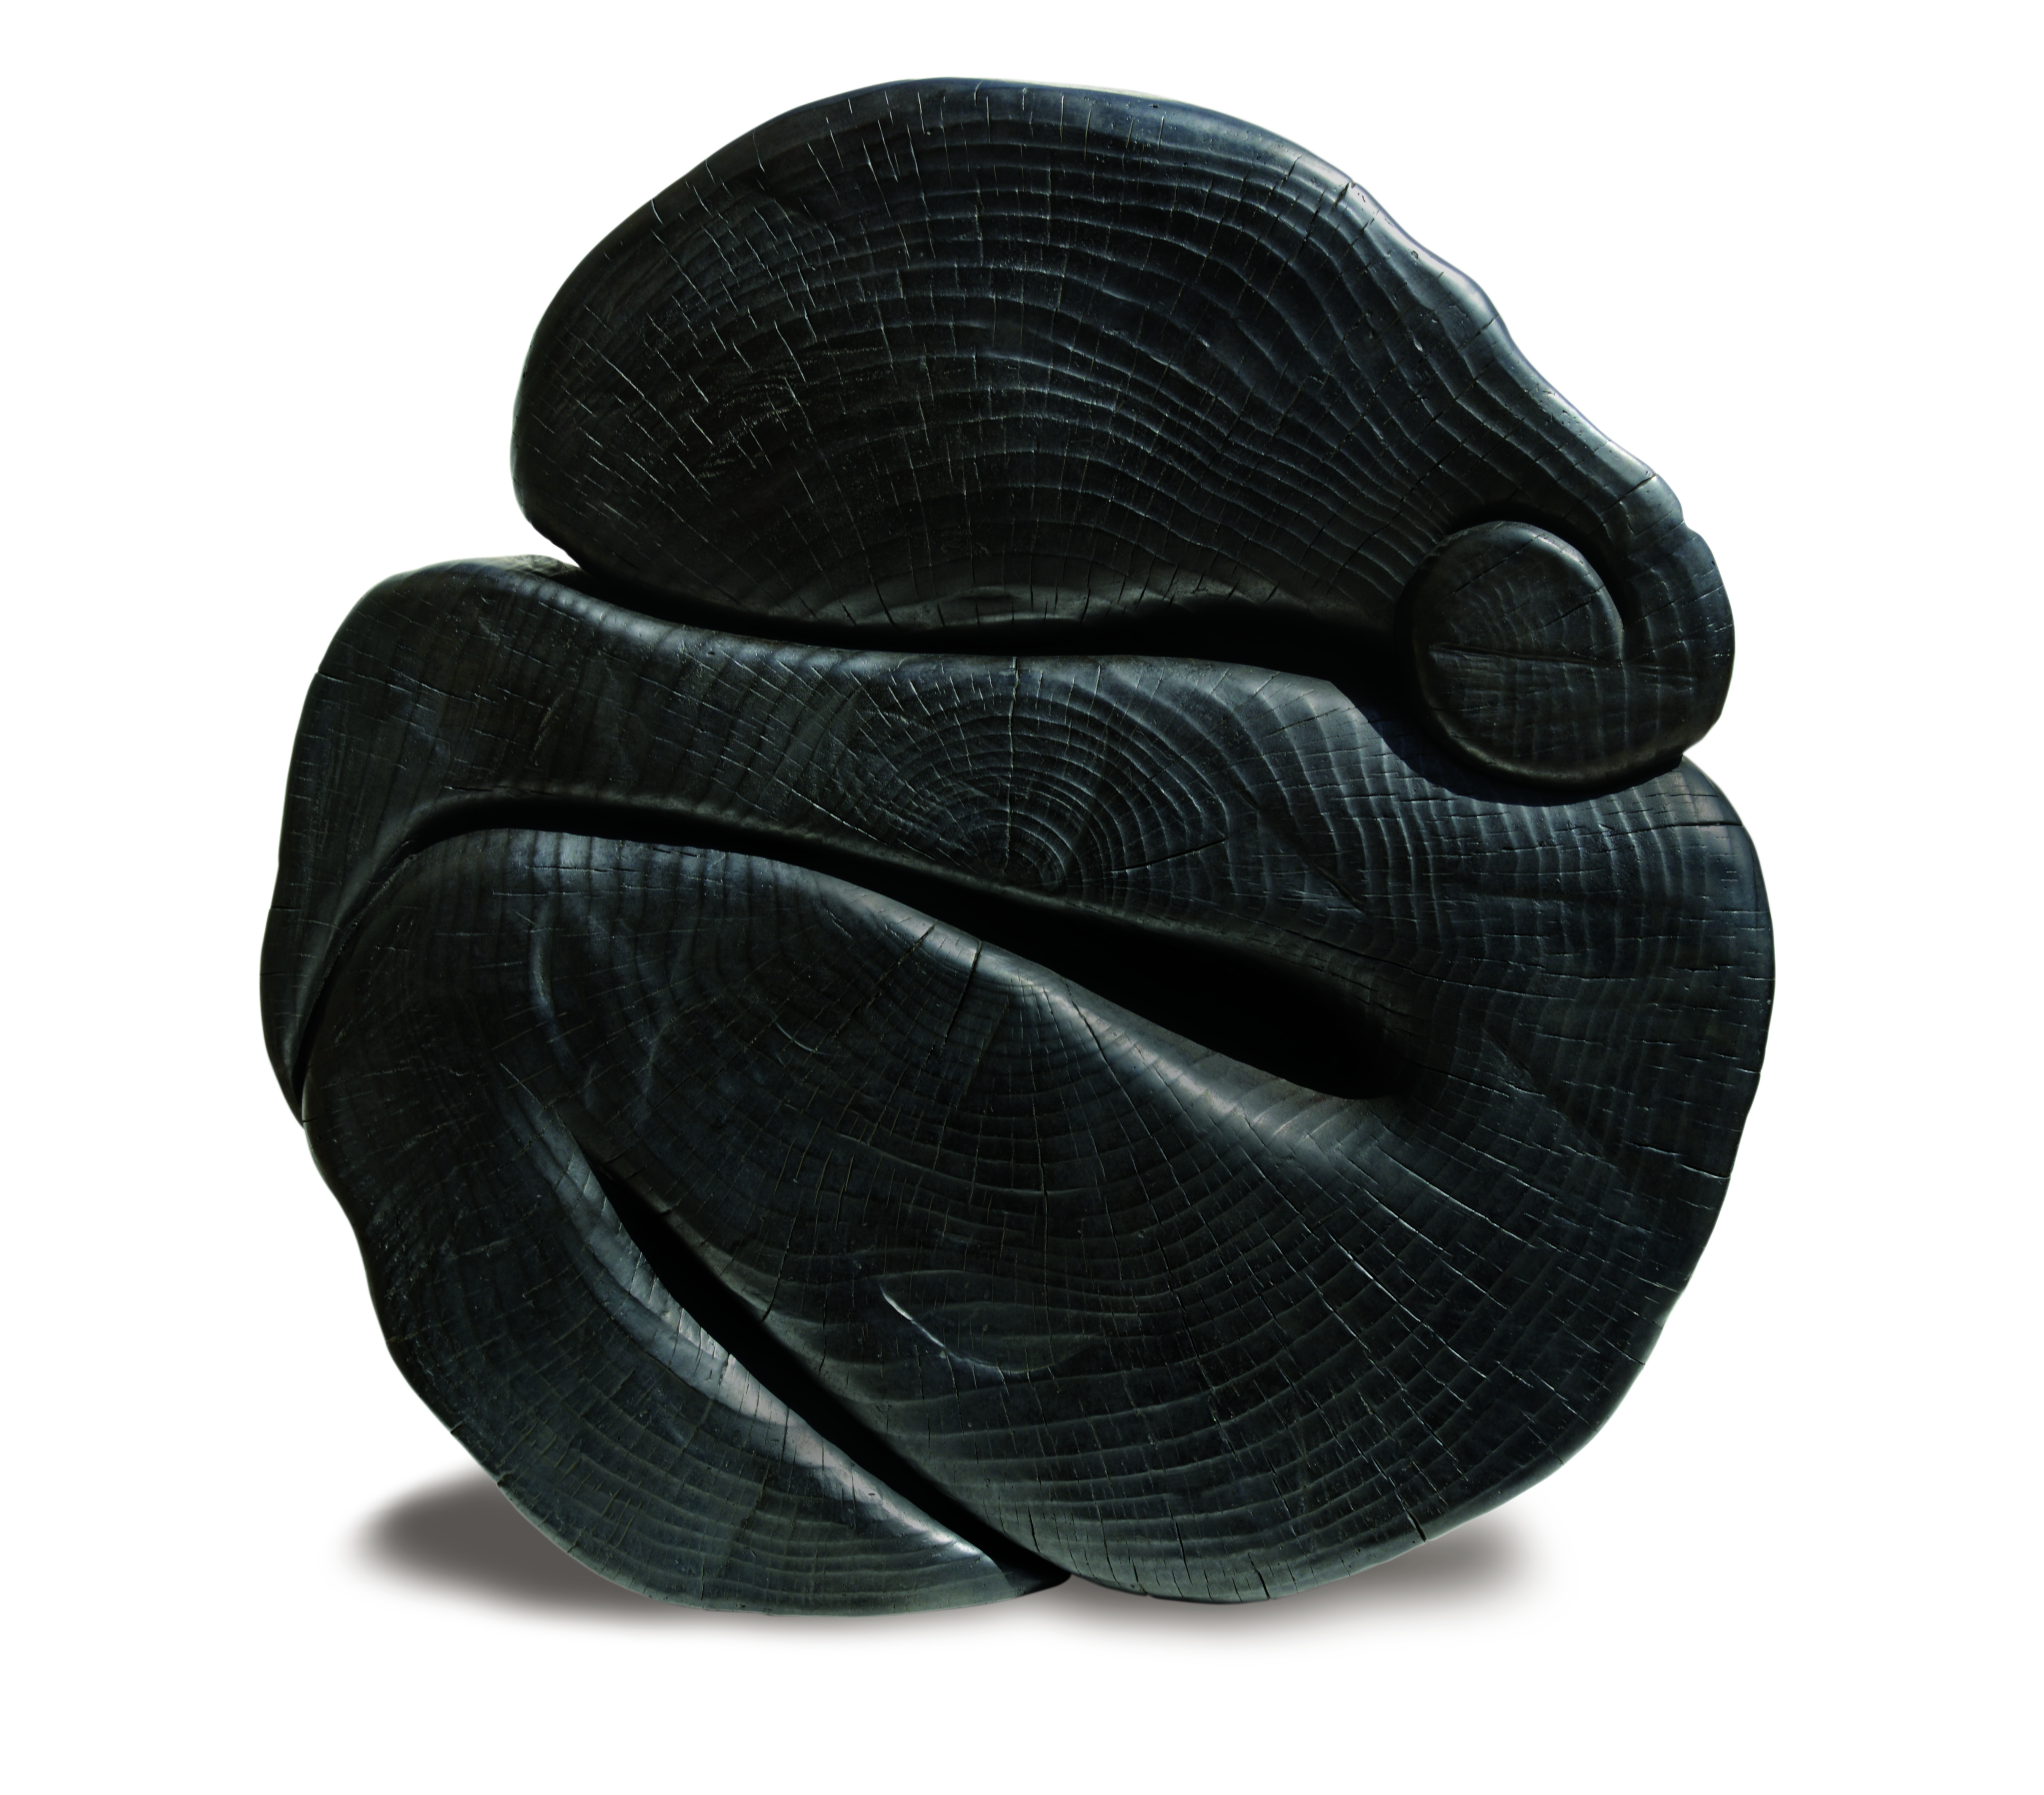

WANG KEPING
17 October – 29 November 2013

Ben Brown Fine Arts is pleased to present the first UK solo exhibition of Wang Keping, one of China’s foremost contemporary sculptors. Wang Keping burst onto the Chinese art scene in the late 1970s as a founding member of the Beijing avant-garde group The Stars (Xing Xing). Featuring over 20 works, the exhibition spans almost 25 years of exceptional artistic production and presents brand new pieces alongside significant creations from the artist’s earlier career.

Wang Keping works almost exclusively in a single medium: wood. The figures and abstract forms in his sculptures seem to emerge organically out of the wood’s grain, knots and flaws. He strives towards simplicity, creating monumental symbols of human nature and sensuality. This exhibition places particular emphasis on his interest in human forms, as demonstrated by the male and female companion pieces Le Matin and La Nuit (1989) as well as newer pieces Yin et Yang (2004) and Renaissance (2013).

Unusual among contemporary artists, Wang Keping completes each sculpture without delegating to studio assistants, a practice attributed to his belief in the intimate nature of artistic production. To prepare the wood for his sculptures, Wang Keping will let logs sit for months, sometimes years, to allow the innate features of the material to grow and deepen until they take on their own distinctive, biologically-determined shapes. Beginning the carving process while the wood is still fresh and moist, Wang Keping encourages cracks to form which eventually dry to form details such as facial features, clenched fists and folds of skin.

Ben Brown Fine Arts will publish a catalogue with a preface by Ai WeiWei to accompany the exhibition. ‘I have known Wang Keping for almost 40 years,’ WeiWei writes. ‘A member of the avant-garde non-conformist artists’ collective, The Stars Group, he has always been seen as the pioneer of contemporary Chinese culture from the late ’70s onwards. His early works have already shown that he is a brilliant artist with a vigorous creative force. At the same time, he actively fights for the right and freedom for artistic expression – the courage and passion he has shown in this regard has been highly influential to me, as well as other artists to come.’

NOTES TO THE EDITOR

Wang Keping was born in Beijing in 1949 and has lived in Paris since 1984. He is a founding member of The Stars (Zing Zing), often called the first avant-garde contemporary art movement in China. His work has been exhibited widely around the world, including in the Centre Georges Pompidou, Musée Maillol and Musée Zadkine in France; in the Kunstmuseum Bern in Switzerland; in the Brooklyn Museum in the US; and in the National Art Museum of China and He Ziagning Art Museum in China. His sculptures have been acquired by several important art institutions around the world including the Fonds Muncipal d’Art Contemporain, Paris; M+ museum, Hong Kong, Musée Cernuischi, Paris; and the Ashmolean Museum, Oxford.

The Ullens Centre for Contemporary Art in Beijing will present an exhibition of the artist’s works from 27 September 2013 – 5 January 2014.

For further press information and enquires please contact:

reiber + partners Ben Brown Fine Arts
Marta de Movellan 12 Brook’s Mews, London W1K 4DG
+44 (0)20 7436 6082 +44 (0)20 7734 8888
marta@reiberandpartners.com www.benbrownfinearts.com
Monday to Friday: 11am - 6pm
Saturdays: 10.30am - 2:30pm

