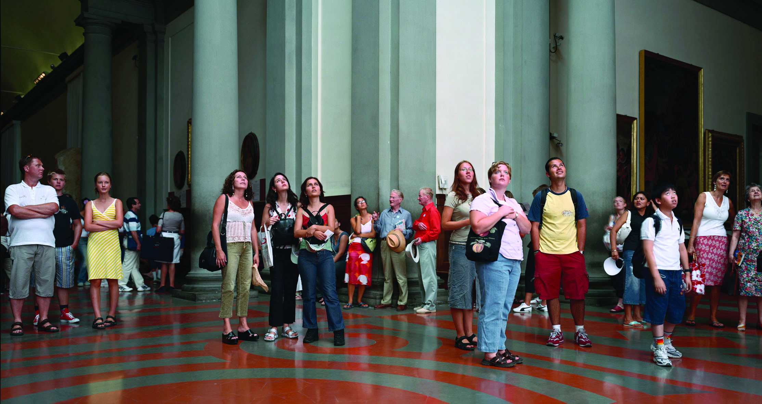
Thomas Struth, Audience 4, Florence, 2004, Chromogenic print, Edition of 10, 178 x 335.8 cm. (70 1/8 x 132 1/4 in.)

EXPRESSION:
A Philosophical Portrait of Humankind,
works selected by Martin Klosterfelde

27 November 2013 – 15 February 2014
Private View: Tuesday 26th November 6 - 8pm

Expression: A Philosophical Portrait of Humankind presents a unique survey of works grouped under the theme of portraiture. While portraiture is a traditional, time-honoured genre, this exhibition offers a new perspective by bringing together iconic portrait paintings by artists such as Max Beckmann, Lucian Freud and Frank Auerbach with more unconventional works by artists such as Lara Favaretto and John Bock.

Many of the conceptual works in this show offer a philosophical portrait of humankind, presented through objects which evoke certain human activities. Ai Weiwei’s Fairytale - 1001 Chairs elevates a mundane household object to an unexpected ebullience of form, but the familiar shape and scuffed feet of these chairs constantly draw the viewer back to their originally intended use as functional objects. Vik Muniz's Self-Portrait (Fall) is another iteration of portraiture, in this case a photographic self portrait of the artist crafted from ferns and other greenery in his trademark style of meticulously arranging and then photographing banal, ephemeral materials to evoke double associations. Not Vital’s sculpture Ingeborg Bachmann commemorates the Austrian poet and writer who died tragically in a fire before completing her final series of books entitled Todesarten (Death Styles). This work displays two silver boxes whose dimensions are related to the date of Bachmann’s death. While the physical form of the sculpture subtly infers the image of a book on a plinth or headstone, its reflective surface draws in the viewer to offer a familiar yet altered reflection of self, allowing the audience to become a component part of the work.

The theme of multiple portraits is continued in the work of Thomas Struth, whose photograph Audience 4, Florence, showing museum spectators gazing upwards, records not just the nuances of the crowd but becomes a portrait of the wonder invoked by an unseen body of artwork. What are the viewers looking at, perhaps another set of portraits? Rirkrit Tiravanija’s pair of glasses Untitled (450/375) remind us that just as humans construct objects, so too, in turn, are humans constructed by objects. There is a forlorn emptiness to the image of unworn spectacles; perhaps the glasses wear the man and not the other way around? Tony Bevan’s anthropomorphic Tree (PC1210) is countered by Gavin Turk’s ironic sculpture of a man (Oscar), both of which deliberately stretch the boundaries of what could be referenced as human.

Expression: A Philosophical Portrait of Humankind explores a number of conceptual themes, often presenting an elusive subject, which relies on the audience’s imagination for completion. The portraits presented in this exhibition hint at, question, and finally augment the viewer’s understanding of what might constitute the subject of a portrait.

For further press information and enquires please contact:

Grace Wong 黄懿琦  +852 9087 1557  grace@benbrownfinearts.com | Rebecca Ko  +852 6779 8230  rebecca@benbrownfinearts.com

Ben Brown Fine Arts
301 Pedder Building, 12 Pedder Street
Central, Hong Kong
+852 2522 9600
www.benbrownfinearts.com
Monday - Saturday, 11AM - 7PM

