Press Release for Immediate Release

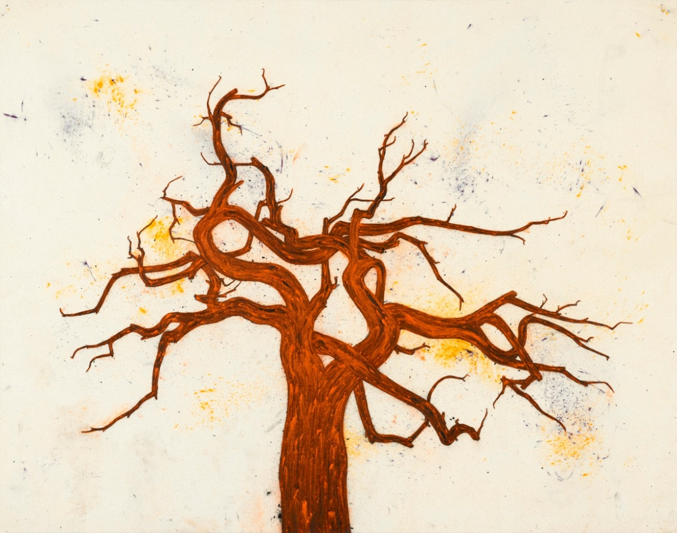
Tony Bevan, Tree (PC1310), 2013, Acrylic and charcoal on canvas, 131.4 x 167 cm; (51 3/4 x 65 3/4 in.)

TONY BEVAN: Chinese Trees
12 September – 1 November 2013
Private View 11 September 6-8 pm

Ben Brown Fine Arts Hong Kong is delighted to present Chinese Trees, an exhibition of new paintings by Tony Bevan, an artist who has been at the forefront of British visual arts for almost thirty years. Bevan’s first foray onto the Asian art scene was in 2008, when he participated in the Building Bridges exhibition at the Today Art Museum in Beijing, showcasing works inspired by a recent trip to China. Chinese Trees is Bevan’s second solo show in Hong Kong, and focuses on an exciting new development in Bevan’s painting over the past two years.

Throughout 2007 and 2008, Bevan travelled extensively throughout China, visiting the cave paintings of Dunhuang, Gansu Province, and the great Buddah at Leshan, both of which influenced his subsequent work. However, the stimulus for Bevan’s new series can be traced to the artist’s discovery of an ancient tree in the courtyard of a temple in the district of Dujiangyan, Sichuan Province. “What attracted me was the tree’s contradictions and the endless forms that came from this—a bit like looking at clouds changing—I set out to explore its full nature, and the forms it held within.” —Tony Bevan

Ranging from large-scale works on canvas to paintings on paper, Bevan highlights the structures inherent in his distinctive pigment-rich skeletal forms, rendering the powerful life force of these trees through the thick lines and marks of pure colour. His use of charcoal and his own pure acrylic pigments gives his painting a remarkably opulent appearance and dramatic tactility. Many of his works are produced while lying flat on the ground of his studio, allowing Bevan to force the pigment into the pores of the canvas or paper.

It is in the artist’s ability to effectively render these trees to their fundamental architectural forms that the direct relationship between Bevan’s Chinese trees, architectural drawings, and figurative heads becomes evident. From one of the most recent works in the series, Tree (PC1310), 2013, to Archive (PC136), 2013 and Head and Neck (PC992), 1999 Bevan’s ability to reduce his subjects to a few intense strokes produces abstracted energetic and emotive formations encouraging contemplation and interpretation. By using the stark repetition of these structural elements to create a sense of rhythm, Bevan effectively uses form and space in order to lead his audience to 'the imaginative space of painting' in which both the art and the viewer can exist.

About Tony Bevan
Tony Bevan studied at the Bradford School of Art (1968–71) and then in London at Goldsmiths' College (1971–74) and the Slade School of Fine Art (1974–76). Since 1976, Bevan has exhibited widely, including his first solo U.S. show at L.A. Louver in 1989. Bevan has also exhibited at the ICA, London, in 1987-88; Staatsgalerie Moderner Kunst Haus der Kunst, Munich, Whitechapel Art Gallery, London and the Israel Museum, Jerusalem, 2003. A major retrospective was presented by the Institut Valencia d’Art Modern (IVAM) in Valencia, Spain in 2005.

In March 2007, Tony Bevan was elected as a Royal Academician of the Royal Academy of Arts in London. His work exists in many prominent international collections such as the Museum of Contemporary Art in Los Angeles, The Metropolitan Museum of Art in New York, The National Portrait Gallery and the Tate Gallery, London.

The artist will be in attendance at the Private View and is available for interviews.

For further press information and enquires please contact:

Tiffany Demont
+852 6056 6115
tiffany@benbrownfinearts.com

Ben Brown Fine Arts
301 Pedder Building, 12 Pedder Street
Central Hong Kong
+852 2522 9600
www.benbrownfinearts.com
Monday-Saturday, 11AM - 7PM

