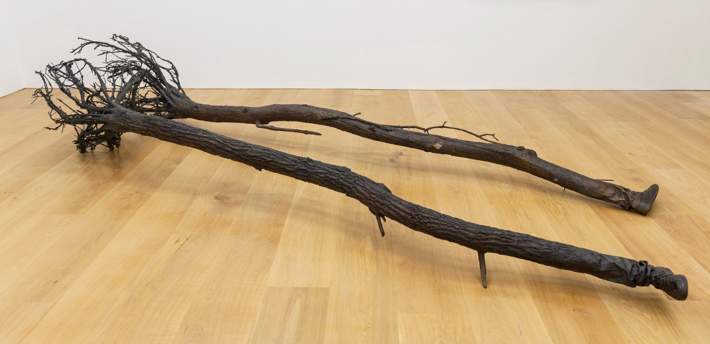
Yoan Capote, Migrants, 2013, Bronze, 2 parts, c. 77 x 476 x 100 cm. (30 1/4 x 187 3/8 x 39 3/8 in.) each

YOAN CAPOTE: EMOTIONAL OBJECTS
12 December 2013 – 29 January 2014
Private View 11 December, 6-8pm

Ben Brown Fine Arts is proud to present EMOTIONAL OBJECTS - the Cuban artist Yoan Capote’s inaugural solo exhibition in London. A leading figure of the burgeoning Cuban art scene, Capote creates psychologically resonant sculptural works in a myriad of media that address a multiplicity of themes - ranging from those of the human condition (isolation, anxiety, desire, claustrophobia, obsession) to cultural identity, migration, politics and the economy.

While Capote’s works are clearly informed by his experiences growing up and living in a politically turbulent and isolated nation, there is a universal dialogue to them that transcends the autobiographical. Despite the serious implications behind his work, there is sardonic playfulness in their presentation, recalling the Surrealists and their interest in the paradoxical. From Will of Power, a monumental ladder affixed to a rocking chair base; to Secreto (Mucho por decir), two rubber molds of ears connected by a soundproof glass tube; to Romance, conjoined umbrellas; and Casados, leather shoes that have been transformed to literally meld into one another, his work promotes immediate humorous associations that go on to reveal more complex issues.

Isla (La Espera) is a sculptural painting fastidiously fashioned from nails, fishhooks and oil paint based on Capote’s childhood memories of growing up on a politically isolated island, longing to know the United States and beyond. What initially registers as a serene, benign seascape turns into a powerful, foreboding image connoting danger and impenetrability as the materiality of the piece is explored. Migrants consists of two slender cast bronze trees that are seemingly uprooted from the earth as they anthropomorphize into human feet that lie futilely on the ground, serving as a metaphor for the physical and psychological conflicts associated with the experience of migration.

The exhibition will also include a steel installation realized exclusively for this show, entitled Lacerante (Mi Silencio), as well as examples of Capote’s highly conceptual photographic work.

The artist will be in attendance at the Private View and is available for interviews. A publication will be produced for this exhibition.

NOTES TO THE EDITOR
Born in 1977, Capote lives and works in Havana, Cuba. He studied at the Instituto Superior de Arte in Havana, and his work has been exhibited extensively in the United States, Europe and Cuba. Capote has received awards and grants from prestigious institutions such as the Guggenheim Foundation, UNESCO, the Pollock-Krasner Foundation, New York, and the Brownstone Foundation, Paris. Notable collections include Museum Beelden aan Zee, The Hague; Arizona State University Art Museum, Arizona; Daros Latinamerica AG, Zurich; Kadist Art Foundation, Paris and San Francisco, California; and the Pizzuti Collection, Columbus, Ohio.

For further press information and enquires please contact:

reiber + partners
Marta de Movellan
+44 (0)20 7436 6082
marta@reiberandpartners.com

Ben Brown Fine Arts
12 Brook’s Mews, London W1K 4DG
+44 (0)20 7734 8888
www.benbrownfinearts.com
Monday to Friday: 11am - 6pm
Saturdays: 10.30am - 2:30pm

